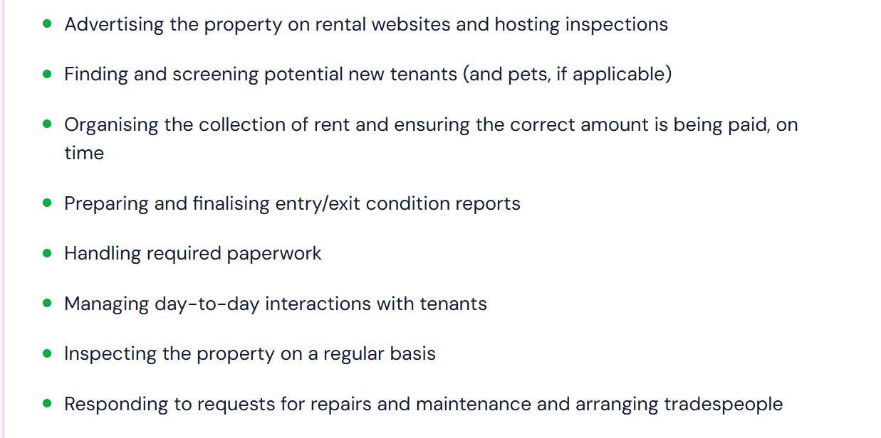

<Business use case: Evaluation>
<Feature: Estimate Rental Price>
Given an address, the service provide an reasonable suggestion on the retal price based on the price of similar and rental type in surrounding area and provide reasoning either in a message format or report format. Data should be automatically fetched externally e.g. realestate.com.au
</Feature: Estimate Rental Price>
</Business use case: Evaluation>

<Business use case: Advertising property>
<Feature: Generate initial listing description>
User put in words/phrase/sentences that describes the property. Output comprehensive and listing-ready listing description.
<example>
<input>
123 High st, Briabane city, $400 per week, bond two week’s rental, available from July 25th 2026, 2b2b, renting master room with independent bathroom, funitured, roommate is phd from UQ, pet friendly, near to gym, air-conditonned, 3min walk to train station.
</input>
<output>
Master Room in Brisbane City – Available Now!
$400/week | Bond: 2 weeks' rent | Available from July 25, 2026
Looking for a comfortable, well-located room in the heart of Brisbane? This could be it!
The Space
Spacious master bedroom with its own private ensuite bathroom, located in a modern 2-bedroom, 2-bathroom apartment right in Brisbane city. The room comes fully furnished, so you can move in and settle straight away — no need to worry about buying furniture.
Stay comfortable year-round with air-conditioning in the apartment.
Location, Location, Location
- 3-minute walk to the train station — easy commuting anywhere in Brisbane
- Close to a gym, perfect for keeping up your fitness routine
- Right in Brisbane city, close to shops, cafes, restaurants, and everything the CBD has to offer
Your Flatmate
You'll be sharing with a friendly, easy-going PhD student from the University of Queensland (UQ) — a great housemate if you value a quiet, respectful living environment.
Pet Friendly 🐾
Got a furry friend? No problem — this home welcomes pets!
</output>
</example>
</Feature: Generate initial listing description>
<Feature: Remind on missing information>
After first generation, remind user on any critical missing information (a set of predefined information category) e.g. address, minimum rental period, number of bedrooms etc. and ask them whether intend to add in the information.
<Feature: Remind on missing information>
<Feature: Remind me what are nearby >
After first generation, user is able to click “Remind me what are nearby” One button generate a selectable list of what facility, natural scene is near by the property. Possible implementation: a)Google map api b) Rely on LLM. Put in selected things to listing description.
</Feature: Remind me what are nearby >

<Business use case: Monitoring and Maintenance>
<Feature: AI Inspection>
AI Read images uploaded and generate inspection report that states the property’s state and flag any potential damage.
</Feature: AI Inspection>
<Feature: Repairment management>
Given a photo evidence sent bak by contractor, use ai to check whether the work is done.
</Feature: Repairment management>
</Business use case: Monitoring and Maintenance>

